DATATYPE : FINANCE DATASET
DATASET : BANK DATASET
Name : Mohammed kaif M Momin

Numerical Data
- Age,
- Annual Income,
- Loan Amount,
- Credit Score,
- EMI Amount,
- Loan Term,
- Account Balance,
- Interest Rate,
- Disbursed Amount
Categorical Data
- Gender,
- Occupation,
- Loan Type,
- Loan Status,
- Bank Branch
- Loan Repayment Status
- Cust ID,
- Cust Name,
- Mobile Number
- Branch Manager
Geological Data
- City,
- State,
Date & Time
- Loan Approval Date

Numeric Data Analysis
- Define Age Column.
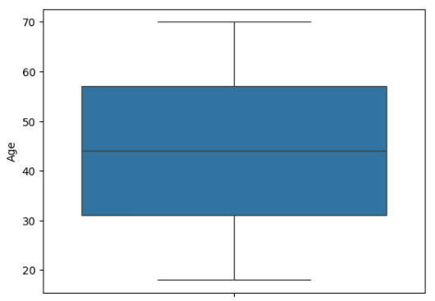
AGE
MIN | 15
MAX | 70
MEAN | 44
STD | 15.29
68%DATA | 29 | 59
CV | 34

In Age column minimum Age of a Customer is 15 & maximum age is 70 that indicate Customers age. We have having minimum age is 15 to maximum age 70 & with the avg age of 44.
We also found that standard deviation of Customers age is 15.29 that means 68% age are from 29 to 59 showing the central concentration of ages. The coefficient of variation (CV) is 34.

2).Annual Income ?

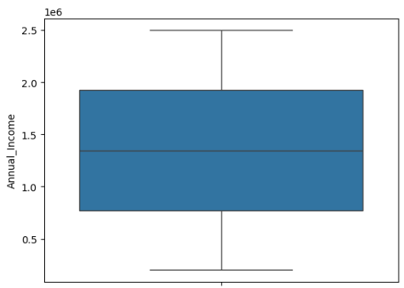
Annual Income
MIN | 2,00,004
MAX | 2,499,999
MEAN | 1,384,861
STD | 664,284
68%DATA | 720,577 | 2,049,145
CV | 47.9

In Annual Income column ,minimum Income of a Customers is 2,00,004 & maximum Income is 2,499,999 that indicate Customers Annual Income. with this information we found average Annual Income of a Customers is 1,384,861.
We also found that standard deviation of Annual Income is 664,284. again that means 68% Customers Annual Income are comes from between 720,577 to 2,049,145 showing the central concentration of Income. The coefficient of variation (CV) is 47.9.

3).Loan Amount
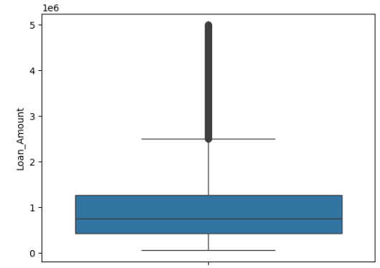
Loan Amount
MIN | 50,010
MAX | 4,999,990
MEAN | 1,097,845
STD | 1,079,367
68%DATA | 18,488 | 2,177,222
CV | 98.3

The Loan Amount column represents the total amount of money borrowed by each customer. The values range from ₹50,010 to ₹40,99,990, with an average loan amount of ₹10,97,585 and a standard deviation of ₹10,79,857, indicating very high variability. The Coefficient of Variation (CV) is 98.3%, showing that loan amounts differ greatly among customers. The box plot highlights several outliers, suggesting that a few customers have taken significantly higher loans than others. These outliers affect the mean and spread of data, so they may need special attention or separate analysis in further reporting.

4).Credit Score

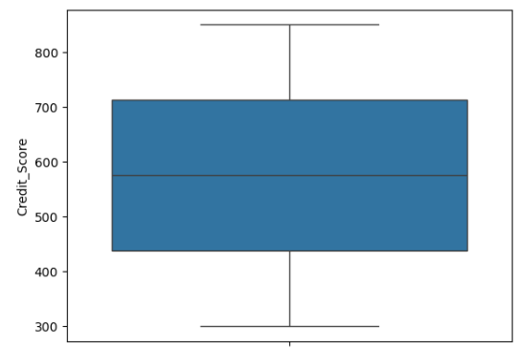
Credit Score
MIN | 300
MAX | 850
MEAN | 575
STD | 158.92
68% | 417 | 733
CV | 27.63

This column shows Customers Credit Score In this column minimum Credit Score is 300 & maximum Credit Score is 850. From that we found average Credit Score of Customers is 575.
We also found that standard deviation of Customers Credit Score is 158.92 again that means 68% Customers Credit Score are from 417 to 733 showing the central concentration of Credit Score. The coefficient of variation (CV) is 27.63.

5).EMI Amount.
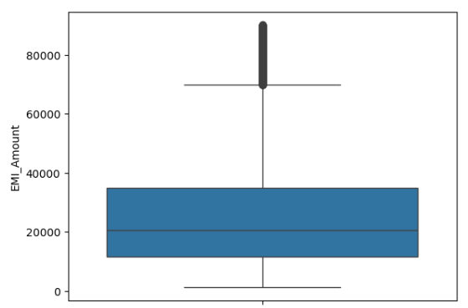
EMI Amount
MIN | 1233
MAX | 90,215
MEAN | 25,212
STD | 17,742
68% | 7,470 | 42,954
CV | 60

The EMI Amount column represents the monthly installment paid by each customer towards their loan. The EMI values range from ₹1,233 to ₹90,235, with an average (mean) of ₹25,212 and a standard deviation of ₹17,712, showing moderate variation among customers. The Coefficient of Variation (CV) is 70%, indicating that EMI payments differ widely based on loan size and duration. The box plot reveals the presence of outliers, meaning a few customers pay much higher EMIs compared to others. These variations are important for understanding customer repayment capacity and loan segmentation.

6). Loan Term
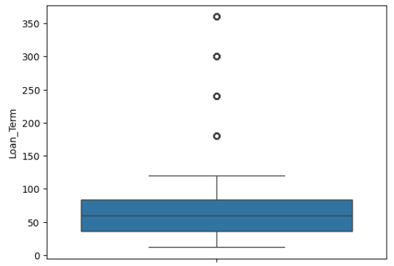
Loan Term
MIN | 12
MAX | 360
MEAN | 84
STD | 89
68%DATA | -5 | 173
CV | 105.9

The Loan Term column represents the duration of the loan repayment period, usually measured in months. In this dataset, loan terms range from 12 months to 360 months, with an average (mean) of 84 months and a standard deviation of 89 months. The standard deviation (89) is higher than the mean (84), showing very high variation in loan durations. This means customers have widely different repayment periods — from very short to very long loans. The Coefficient of Variation (CV) is 105.9. The box plot indicates a few outliers. This analysis helps in understanding repayment patterns and identifying customers with short-term versus long-term loans.

7). Account Balance
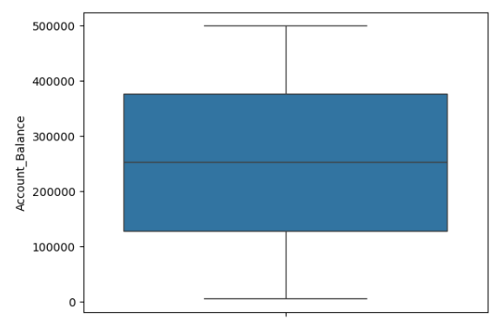
Account Balance
MIN | 5002
MAX | 4,999,995
MEAN | 252,676
STD | 143,048
68%DATA | 109,628 | 395,724
CV | 56.6

In Account balance column minimum Balance of a Customers is 5002 & maximum is 4,999,995 that indicates Customers Account Balance. with that we found the avg balance of customers account is 252,676.
We also found that standard deviation of Account Balance is 143,048 again that means 68% Customers Balance are between 109,628 to 395,724 showing the central concentration of account Balance. The coefficient of variation (CV) is 56.6.

8). Interest Rate
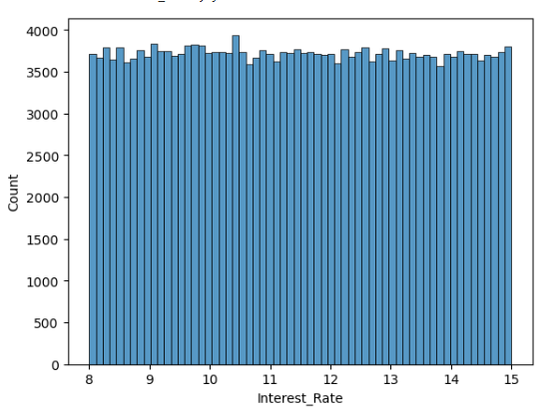
Interest Rate
MIN | 8
MAX | 15
MEAN | 11.49
STD | 2.02
68% | 9.4 | 13.4
CV | 17.5

The Interest Rate column represents the percentage of interest charged on each customer’s loan. The values range from 8% to 15%, with an average (mean) of 11.49% and a standard deviation of 2.02, indicating low variability in interest rates across customers. The Coefficient of Variation (CV) is 17.5%, showing that most customers have similar interest rates. The bar chart displays a fairly uniform distribution, meaning interest rates are consistently applied within a narrow range for most loans.

9). Disbursed Amount

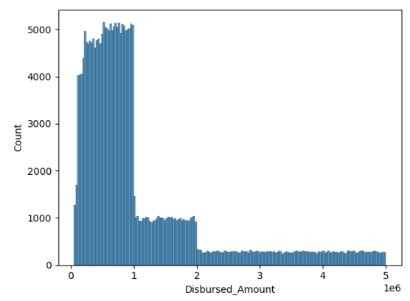
Disbursed Amount
MIN | 50,010
MAX | 4,999,960
MEAN | 1,095,845
STD | 1,079,367
68% | 16478 | 2,175,212
CV | 98.4

The Disbursed Amount column represents the total loan amount approved and released to each customer. The values range from ₹50,010 to ₹40,99,960, with an average (mean) of ₹10,95,845 and a standard deviation of ₹10,79,367, showing very high variation among customers. The Coefficient of Variation (CV) is 98.4%, indicating a wide spread in disbursed amounts. The histogram reveals that most customers received smaller loan amounts, while a few customers received much larger loans, creating a long right tail (positive skew) in the data distribution.

CATEGORICAL COLUMNS

1). Distribution of Gender in dataset?

GENDER
Male | 77,146
Female | 76,744
Others | 76,594
Total | 2,30,

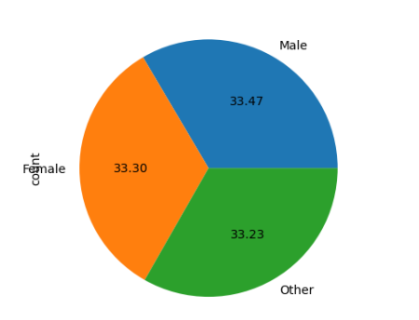

The dataset contains information on 2.3 lakh customers, categorized by gender. Out of these, 77,146 are Male (33.47%), 76,744 are Female (33.30%), and 76,594 are classified as Others (33.23%). The pie chart shows that the gender distribution is almost equal, indicating a well-balanced representation across all gender categories.

2).Distribution of Occupations in dataset?

Occupations
Retired | 20.1%
Student | 20%
Self Employed | 20%
Unemployed | 20%
Salaried | 20%

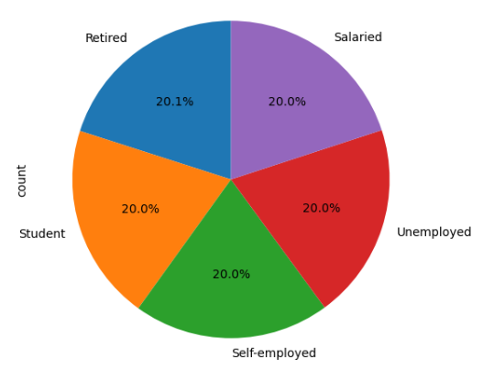

The dataset includes five major occupation categories — Retired, Salaried, Unemployed, Self-Employed, and Student — each contributing approximately 20% of the total population. The pie chart shows an even distribution across all occupation types, indicating that the dataset represents a diverse mix of individuals from different employment backgrounds. This balance helps ensure that any insights or models developed from the data are equitable and unbiased toward any specific occupation group.
3).Loan Type
Loan Type
Car Loan | 20.1%
Home Loan | 20.1%
Education Loan | 20%
Personal Loan | 19.9%
Goal Loan | 20%

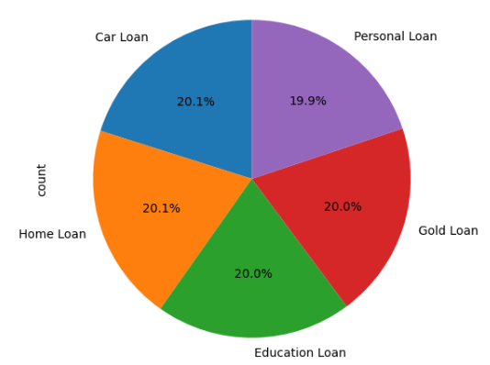

The dataset includes five major loan categories — Car Loan, Home Loan, Education Loan, Personal Loan, and Gold Loan — each contributing roughly 20% to the total loan portfolio. The pie chart shows an almost equal distribution across all loan types, indicating that the bank serves a diverse range of customer needs rather than focusing on a single loan category. This balance highlights the bank’s broad lending strategy and supports fair analysis across different loan products.

4).Loan Status.
Loan Status
Closed | 33.4%
Default | 33.3%
Active | 33.3%

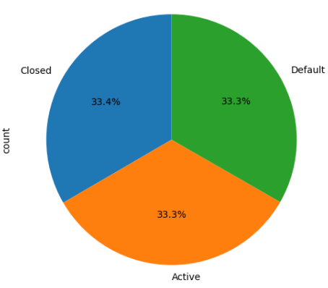

The dataset shows that the loan status is evenly distributed among three categories — Closed, Default, and Active — each covering approximately 33% of the total records. This balanced distribution helps in analyzing the overall loan performance, allowing equal focus on repaid loans, ongoing loans, and default cases.

5).Bank Branch

Bank Branch
Mumbai | 25.2
Bangalore | 24.9
Delhi | 24.9
Kolkata | 25.1

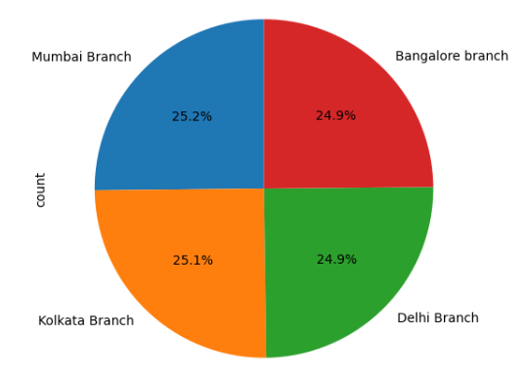

The dataset shows a balanced distribution of customers across all four branches — Mumbai (25.2%), Bangalore (24.9%), Delhi (24.9%), and Kolkata (25.1%). This even spread indicates that each branch contributes almost equally to the overall customer base, helping maintain consistent performance and workload distribution among branches.

6). Loan Repayment Status

Loan Repayment Status
Completed | 33.5
Pending | 33.3
Deferred | 33.2

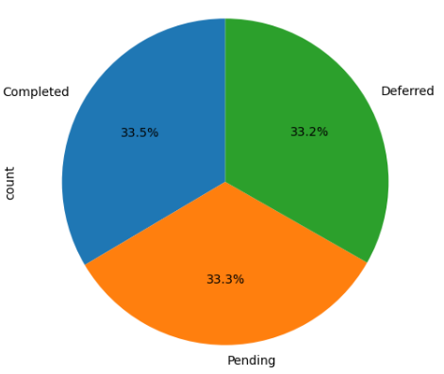

The dataset shows an almost equal distribution among the three repayment categories — Completed (33.5%), Pending (33.3%), and Deferred (33.2%). This balanced proportion indicates that the dataset includes a fair mix of customers at different loan repayment stages, which is useful for analyzing repayment patterns and financial behavior.

GEOLOGICAL
- State
State
Maharashtra | 12.6
Karnataka | 12.6
West Bengal | 12.6
Delhi | 12.6
Andhra Pradesh | 12.5
Rajasthan | 12.5
Uttar Pradesh | 12.4
Tamil Nadu | 12.3
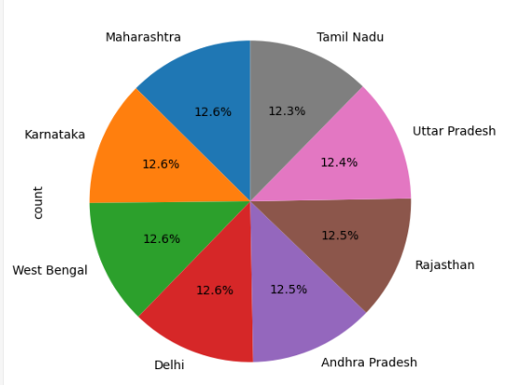

The dataset shows an almost uniform distribution of customers across all eight states, with each state contributing around 12–13%. Maharashtra, Karnataka, and West Bengal have slightly higher proportions (12.6%), while Tamil Nadu has the least (12.3%). This balanced spread ensures a diverse geographical representation in the dataset.

